CONCERT

at
ST. NICHOLAS CHURCH, BARTON-LE-CLAY

October 3rd 2012 at 7.30 pm.
The programme will include:
The ‘Wesendonk Lieder’ by Wagner,
‘Sea Pictures’ by Elgar
and songs by
Mahler, Reynaldo Hahn, Delius and Kerry Woodward

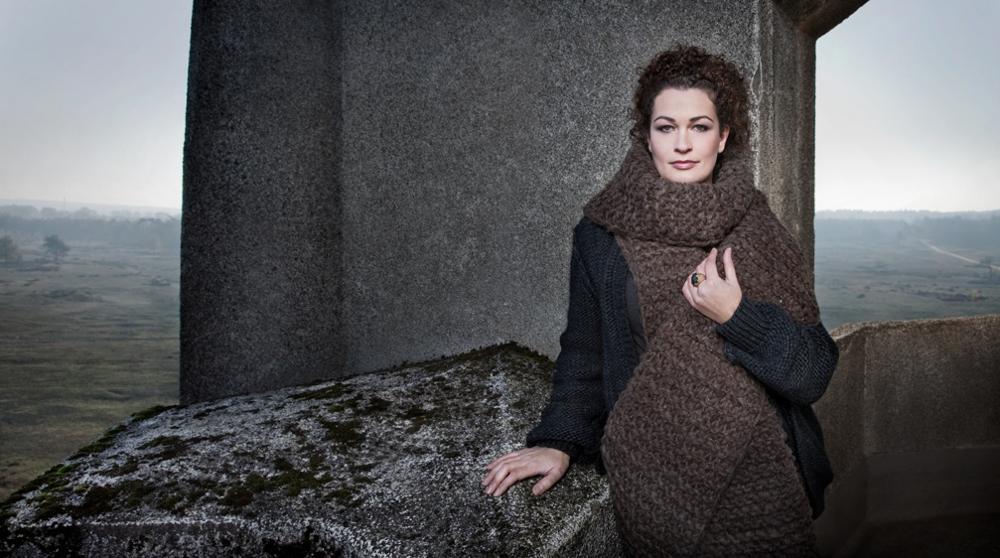

Janneke Schaareman – Mezzo-soprano
The Dutch mezzo-soprano Janneke Schaareman has delighted audiences with her many operatic roles – for example the Third Lady in Mozart’s “The Magic Flute”, the Sorceress in Purcell’s Dido and Aeneas, Orpheus in Gluck’s “Orfeo et Euredyce”, and the title role in Bizet’s “Carmen”. She is also a regular soloist in contemporary operas.
With pianist Cathelijne Maat, Janneke has formed the lied-duo ‘Ondine’ and they have given recitals in Holland, France and Belgium. Recently, she performed at the Uitmarkt Amsterdam Festival, the Festival Classique Den Haag and the Schubert Festival in Belgium. Janneke has also created and performed for many years in music-theatre with ‘Ensemble Xantippe’.
Recently Janneke took part in the “Transmusings” project to perform and record music composed by the philosopher Nietszche, as well as by composers such as Delius, Mahler, Rihm and Woodward who were particularly inspired by him.

LIGHT REFRESHMENTS DURING THE INTERVAL
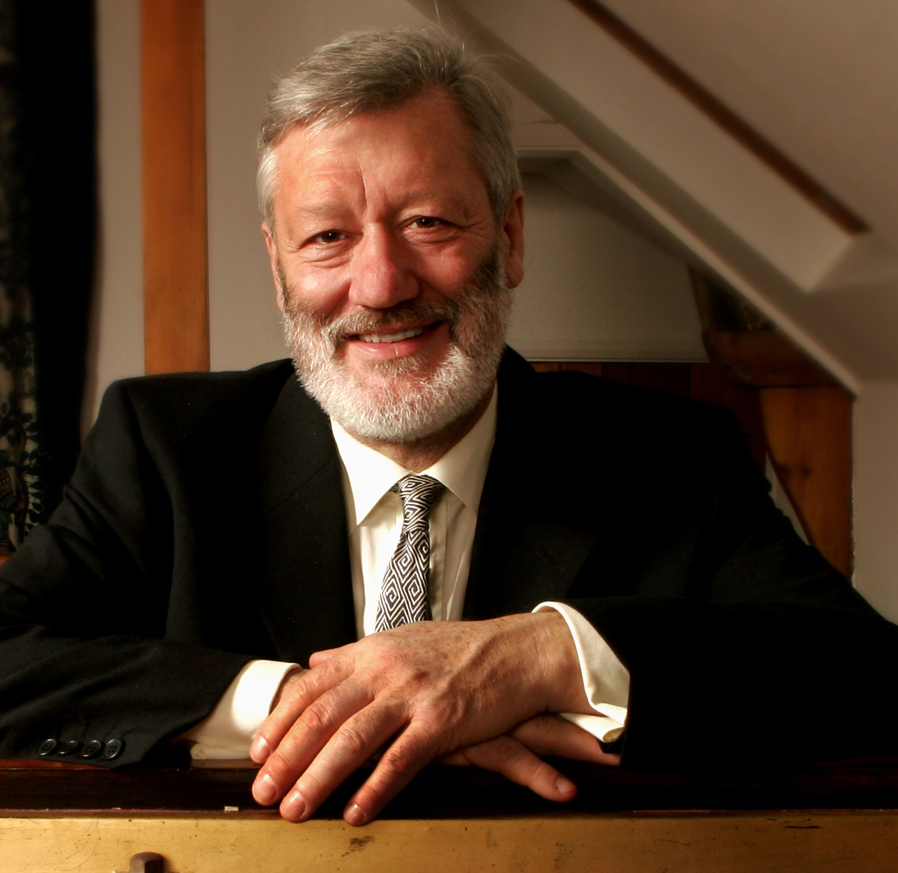
The pianist Simon Marlow enjoys a busy career with frequent concert appearances in Britain and many other European countries as well as recitals in the United States, Sri Lanka and Iceland. He has appeared with the Scottish Chamber Orchestra, broadcasted and made several recordings. Simon has worked for many years with the Medici Quartet violist, Ivo-Jan van der Werff with whom he has toured and recorded. Simon has also established a recital and recording partnership with the violinist Shulah Oliver, with a particular emphasis on the many marvellous works by English composers for violin and piano. Last year Simon also took part in the same “Transmusings” project as Janneke. In addition to his musical interests, Simon worked for ten years with the Lucis Trust, an educational charity, and has made (for his sins!) several forays into local politics.

TICKETS £8 (CONCESSIONS £6.50) Available from Tony Howells 01582 881611 (t.howells08@btinternet.com )
or Doug Scott 01582 881844 ( dougscott@tinyonline.co.uk)
PROCEEDS TO THE REPAIR AND RESTORATION OF ST. FAITH’S & ST NICHOLAS CHURCHES

Simon Marlow – Piano

